Search Articles

Path URL: https://english.xynie.com/

Screenshot:
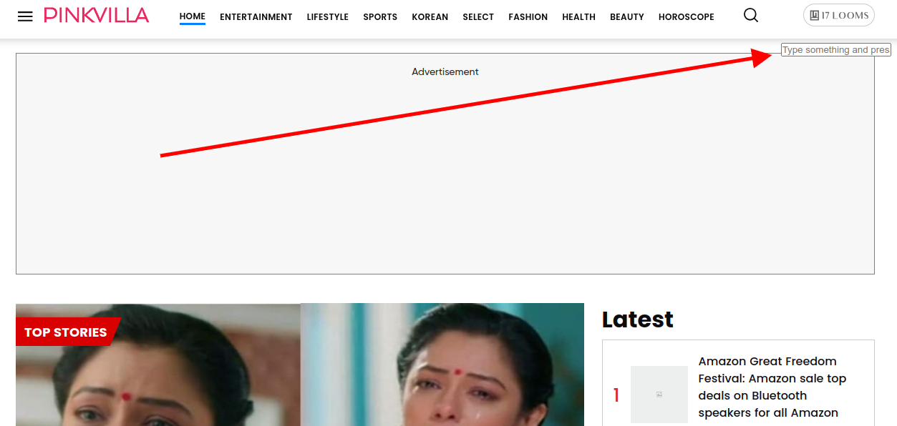

Logic: When clicked on the search icon, a small input box appears under that icon. Search input to search articles using article id, keywords or slug

Cron Job: Not required

Setting in the CMS: Not required

Code:

List of Source Files:
-Frontend
/var/projects/english-frontend/routes/web.php
/var/projects/english-frontend/app/Http/Controllers/SearchController.php
/var/projects/english-frontend/resources/views/desktop/layouts/headerV3.blade.php
/var/projects/english-frontend/resources/views/desktop/pages/sectionv2/search.blade.php
/var/projects/english-frontend/resources/views/desktop/widgets/sectionv2/search-first-row.blade.php
/var/projects/english-frontend/resources/views/desktop/widgets/sectionv2/search-rows.blade.php

